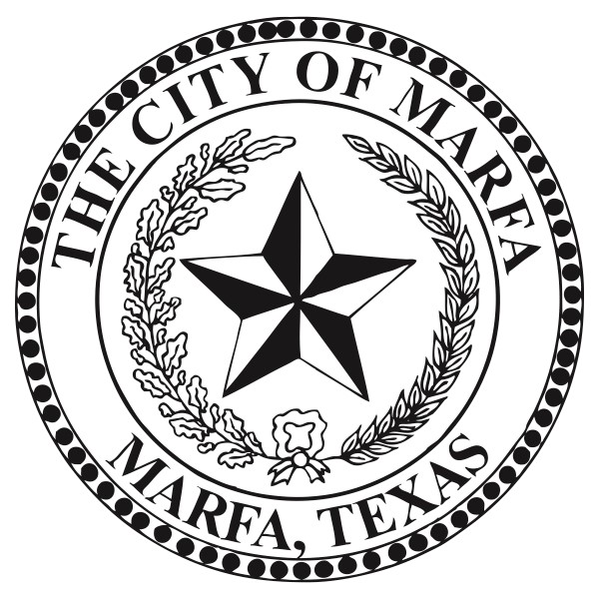

Hotel Occupancy Tax (HOT) Fund
Arts & Culture Grant

APPLICATION

Section A, Organization Information
Organization Name
Physical Address
Mailing Address
Contact Name
Contact Phone Number
Web Site Address for Event or Sponsoring Entity
Non-Profit or For-Profit status: Tax ID #:
Entity’s Creation Date
Purpose of your organization:

ARTS & CULTURE GRANT APPLICATION

Section B, Project Information
Name of Event or Project
Date and Location of Event or Project
Amount Requested: $

Project Eligibility
- Will the proposed activity, if funded, directly enhance and promote tourism in Marfa, Texas?
____Yes ____No
- If funded, will the grant clearly pay for advertising, solicitations, and promotional programs planned to attract tourists and convention delegates or registrants to the municipality or its vicinity?
____Yes ____No

Project Narrative
Please use the following page to tell us about your event and include the following information:
- What is the primary purpose of the activity or project which you are advertising or promoting?
- How will this activity directly enhance and promote tourism in Marfa?
- How many years have you held this event?

One-Page Project Narrative Tourism Outcomes
- How many people do you expect to attend your event or activity?
- How many people in attendance do you expect will come from outside of the tri-county area?
- How many do you expect will rent rooms in Marfa?
- How many nights do you expect they will they stay?
- Will you reserve a room block at an area hotel and if so, for how many rooms and at which hotels?

- How will you measure the impact of your event on area hotel activity (e.g.; room block usage information, survey of hoteliers, etc.)?

- If your grant request is for promoting ongoing programming at a permanent facility (e.g.
museum, visitor center):
  - What was your organization’s annual attendance last year?
  - What percentage of your visitors come from outside the tri-county area?

Budget
- Will you charge admission? If so, what is the admission cost?

- Do you anticipate a net profit from the event? If there is a net profit, what is the anticipated amount and how will it be used?

- On the following page, please submit a budget for your project, including anticipated funding from HOT, other organizations, and other grants or donations.

One-Page Project Budget

Section C, Promotion
Please give us details about your promotional plan. How do you plan to reach an audience outside of the tri-county area and bring them to Marfa to attend your event?

Section D, Assurances
If an Arts & Culture Grant is awarded, the applicant hereby assures the City of Marfa that:
- The activities and services for financial assistance sought will be administered by the applying organization.

- Any funds received through this application will be solely used for the event described.

- Proper credit will be given to the City of Marfa, using its tourism logo on all advertising and promotion of the event.
- The undersigned have been authorized by the applicant to submit this application.

President or Chairman
Date
Project Director
Date

Section E, Application Checklist
Please confirm you have fully completed and included the following:
  - Section A, Organizational Information

  - Section B, Project Information
    - Eligibility
    - Narrative
    - Outcomes
    - Budget

  - Section C, Promotion

  - Section D, Assurances

Please submit your application electronically by 5:00 pm on deadline. Late applications will be considered based on availability of funds. Please submit via email to jconners@cityofmarfa.com

